Planning: STOPS Model Process

**Objective/Purpose/ Why:** The Simplified Trips-on-Project Software (STOPS) is a series of programs designed to quickly produce plausible forecasts of transit project ridership using readily available census data, transit ridership and schedule information, and metropolitan planning organization forecasts of demographic growth.

**Subject Matter Expert:**

Jeffrey Roux

Federal Transit Administration

Office of Planning and Environment

(202) 366-1806

[jeffrey.roux@dot.gov](mailto:jeffrey.roux@dot.gov)

Tim Simon

Alliance Transportation Group

Office 512.821.2081 | Mobile 541.600.0515  [tsimon@emailatg.com](mailto:tsimon@emailatg.com)

Jack Jones

Alliance Transportation Group

Mobile 512.927.6834  [jjones@emailatg.com](mailto:jjones@emailatg.com)

**Process:**

1. Request Travel Demand Model from area to be modeled.
2. Download the most recent STOPS version to designated computer. Follow installation instructions as outlined in the STOPS documentation which can be found in the link/directory below –

[STOPS - Documentation and Software | FTA (dot.gov)](https://www.transit.dot.gov/funding/grant-programs/capital-investments/stops-documentation-and-software)

FTA website only contains an older version of STOPS as of this writing. Most recent STOPS version (software & users guide) available in-house – **Z:\Planning\Transportation Planning References\software\STOPS fhwa\STOPSv2.5.**

1. Prepare STOPS input data.
   1. Census inputs – STOPS allows two sources of data to be used Census 2000 or ACS 2006-2010. Use the ACS data as more recent and the software has been optimized to use ACS.

[STOPS – Data from the Census | FTA (dot.gov)](https://www.transit.dot.gov/funding/grant-programs/capital-investments/stops-data-census)

FTA website FTA website only contains the Census 2000 data as of this writing. Contact FTA (Jeff Roux) to receive the preferred ACS data. Texas ACS data can be found in-house – **Z:\Planning\Transportation Planning References\software\STOPS fhwa\STOPSv2.5.**

* 1. Travel Demand Model – STOPS requires two pieces of data from the travel demand model.
     1. TAZ layer in shp format with total population and total employment by TAZ. This includes the current and forecast years. Interpolating and/or extrapolating to match project years is acceptable. See STOPS User’s Guide for formatting.
     2. Zone to zone auto travel time generated from the travel demand model congested travel times. A peak period is preferred. This includes the current year and forecast years. See STOPS User’s Guide for formatting.
  2. **GTFS (See Appendix at bottom for more detail) – General Transit Feed Specification (GTFS) files may be obtained from the client or downloaded from Remix. The process for editing and formatting GTFS are as follows:**
     1. **Data Download (REMIX ONLY):** Data can be downloaded after validating the correct assumptions, route alignments, stops, and route characteristics (span, average vehicle speed, frequency, and utilization).
     2. **Raw Data**: Save backups of the original GTFS.
     3. **Importing**: Import the .txt files that require edits into excel.
     4. **Working file**: Write formulas in a .xlsx and saving as a backup in case more changes need to be made. Edits that are typically made include[1]:
        1. **routes.txt:** Convert route_id in routes.txt into a readable unique id
        2. **trips.txt:** Ensure route_id in trips.txt matches the new route id created in route.txt using VLOOKUP
        3. **stops.txt:** Create a unique stop_id in the stops.txt file
        4. **stop_times.txt:** Ensure that the stop_id in stop_times.txt matches the new stop id created in stop_times.txt using VLOOKUP
        5. **agency.txt:** check agency URL, agency ID, and timezone
        6. **calendar.txt:** check start and end date
     5. **Working file QC:** The working file should be QC’ed before moving on the next step to prevent re-work.
     6. **Exporting**: Save as .csv from each excel tab from the working file, this should not overwrite your working copy from before but give you individual files for which to use. Methods for doing this are included below:
        1. **Paste as Value**: Before saving each .csv from each tab in the working file:
           1. Save your working file FIRST
           2. Paste all columns as values for all tabs

This removes any/all formulas

* + - * 1. Then you can clean up the columns back to the original list of columns in the GTFS and remove any “working” columns
        2. Do not hit save while you are doing these steps-

This would accidentally remove the formulas from your working file which is important to have for QC or easy fixes later

* + 1. **Exporting**: Resave the exported .csv back to a .txt file so that it can be opened and edited in Visual Studio Code. After saving to .txt file, quotations (“ “) will need to be added around each item.
    2. **Testing**: Use the GTFS Validation tool to check for major errors.
    3. **Testing**: Have someone enter them into STOPS to check for any errors. Note that several iterations of “Testing” may be required to validate the final GTFS files.
  1. Other inputs not required but preferred.
     1. Total unlinked trips (total current system boardings). Input directly into the STOPS interface. While not required for the model should be included.
     2. Route counts (total boardings by route). Input as a separate file. See STOPS User’s Guide for formatting. While not required for the model should be included.
     3. Boarding counts by stop. Input into the stop locations shp file after created by the STOPS model.

1. Determine STOPS method.
   1. Synthetic – If transit OD survey not available.
   2. Incremental – If transit OD survey available (preferred). See STOPS User’s Guide for formatting/creating trip table from survey data. Input as a separate input file.
2. Create STOPS run directory structure. See User’s Guide for format or find an existing run for an example.

Typical STOPS Application

**1)** Open STOPS executable. See **Figure 1** below.

* 1. Associate STOPS to the most recent version of TransCAD or ArcMap

F**igure 1: STOPS Interface**

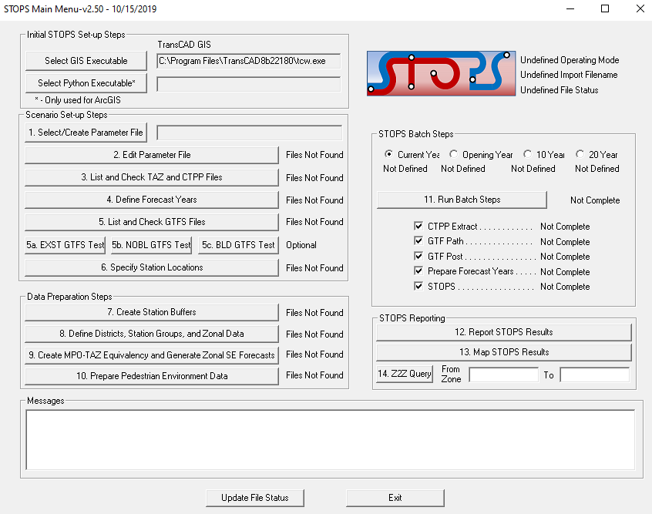

b. Create the Parameter/Control File. Can start with a file from another project and revise. See **Figure 2** below. See User’s Guide for input definitions.

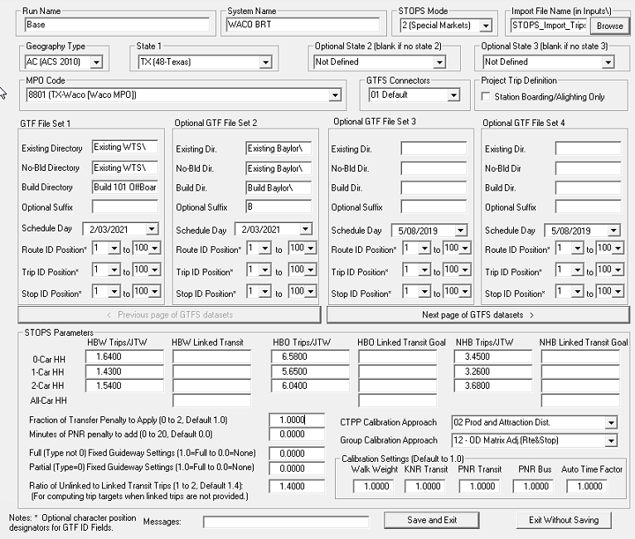

**Figure 2: Parameter/Control File**

**2)** Use STOPS defaults for initial calibration for the STOPS Parameters shown in **Figure 2**.

1. Defaults can be adjusted thru the calibration
2. Regional calibration criteria – 0.7 to 1.4. See Table 2.04 in STOPS output file. Use *Report STOPS Output* button
3. Route criteria – within 40% of route count. See Table 2.08 in STOPS output file. Use *Report STOPS Output* button.
4. Once validation achieved apply STOPS parameters to No-Build and Forecast GTFS files.
5. Review Table 10.05 in STOPS output for reasonableness and logic. Use *Report STOPS Output* button.

**Outcome:**

STOPS produces Project and System ridership by route, stop, and geographic aggregation and by several modes. This data can be used for CIG / Small Starts applications as well as general project level analyzes.

**Resources:**

FTA is very forthcoming in providing help throughout the modeling process. Jeffery Roux, noted above is a very good resource to get your particular project up and running.

The directories below contain very good reports/power points describing the operation of the STOPS model.

*Z:\Planning\Transportation Planning References\STOPS*

*Z:\Planning\Transportation Planning References\software\STOPS fhwa*

**Definitions:**

ACS –American Community Survey

APC –Automatic Passenger Counter

APTA –American Public Transportation Association

BRT –Bus Rapid Transit

CFRPM –Central Florida Regional Planning Model

CIG –Capital Investment Grant

CRT –Commuter Rail Transit

CTPP –Census Transportation Planning Package

FGS –Fixed Guideway Setting

FTA –Federal Transit Administration

GTFS –General Transit Feed Specification

HBO –Home-Based Other

HBW –Home-Based Work

HRT –Heavy Rail Transit

JTW –Journey-to-Work

KNR –Kiss-and-Ride

LRT –Light Rail Transit

LRTP –Long Range Transportation Plan

MPO –Metropolitan Planning Organization

NHB –Non-Home Based

NTD –National Transit Database

NTI –National Transit Institute

PNR –Park-and-Ride

PMT –Person Miles Traveled

STOPS –Simplified Trips on Project Software

TAZ –Traffic Analysis Zone

TCAR –Transit Concept and Alternatives Review

VMT –Vehicle Miles Traveled

Appendix A – GTFS feature conversion in ArcGIS Pro

GTFS to Feature Conversion in ArcGIS Pro

# Identify the Geoprocessing panel and type GTFS in the *Find Tools* search bar.

# Select either the “GTFS Stops To Features” or the “GTFS Shapes To Features” conversion tool.

# Navigate to the location of the input GTFS file you intend to convert. If you are using the Stops conversion tool, select the stops.txt file. If you are using the Shapes conversion tool, select the shapes.txt file.

# Navigate to the location of the geodatabase where you want to save the output feature class. You can either create a new name for the output feature class or use the auto-generated name that GIS provides.

# Press the Run button at the bottom of the panel to begin the file conversion. The output feature class will automatically be added to your map.

1. Additional edits may be needed